News Communities Allen

Allen

Cardio-drumming classes in Allen attract all ages
Facebook | Twitter | Email | Comment | Print

By HEATHER NOEL hnoel@neighborsgo.com
Neighborsgo
Published: 19 December 2014 06:28 AM
Updated: 19 December 2014 06:28 AM
Related
Don Rodenbaugh Natatorium
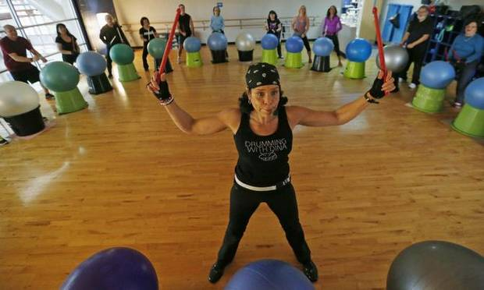

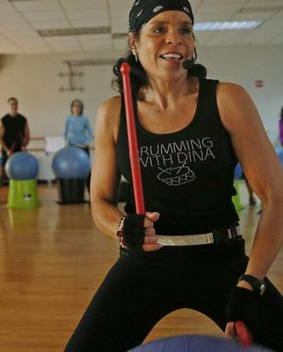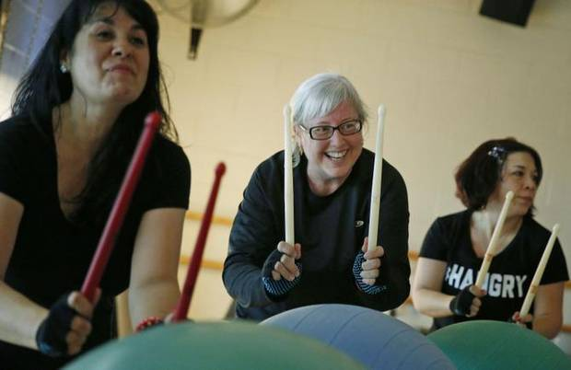

Map

Wednesdays at the city of Allen’s Don Rodenbaugh Natatorium are all about the beat.
As a mix of Iggy Azalea’s song “Fancy” blares out of the stereo, pounding drumsticks vibrate the floor.
“We about to get fancy,” Dina Scott says to a crowd that erupts in cheers.
The sounds aren’t coming from a teenage cover band, but a group of men and women who beat drumsticks on plastic exercise balls — all in the name of fitness.
Cardio drumming is one of the newest group exercise classes at the natatorium. Combining aerobic movement with the beats and rhythm of drumming, the class has attracted some fitness drumming diehards and others curious about the exercise format.
“It’s something that’s just so different,” said center supervisor Quinn Ray. “When people see the sign … they just have no idea what that could be, so they’re immediately interested.”
For the workout, participants use plastic drumsticks to beat on exercise balls perched atop plastic bins. Participants are arranged in lines or a semi-circle, and alternate between beating the balls to the left, right and directly in front of them.
Ray said the class has brought in some people who are not members of the natatorium, mostly through word of mouth.
Although it’s a relatively new offering to the Allen area, fitness drumming has been popular in other parts of the world for years.
Carrie Ekins, founder of Drums Alive, created her Germany-based program more than a decade ago and Los Angeles-based Pound, which is a fitness drumming program without exercise balls, began about three years ago.
Scott, who has more than 15 years of experience in fitness instruction, is certified in both programs, but prefers to follow the Drums Alive model, she said. She is one of six instructors certified in Drums Alive in Texas.
“It’s low impact in terms of the impact it has on your body, but it’s still intense to get your heart rate up and burn calories,” Scott said.
One exercise fits all
Elizabeth Kennedy, a 57-year-old Allen resident, said she was hesitant to try the 45-minute drumming class since she hadn’t exercised in years.
“I was concerned that I couldn’t keep up, but then I was surprised to find that I could keep up,” Kennedy said.
Now she’s hooked. She takes 11 classes a week with Scott, including Zumba and cardio drumming.
“She pushes you in a fun way to do better, and that’s what I like,” Kennedy said. “[Cardio drumming] doesn’t feel like exercise, it doesn’t seem like exercise; it’s something that’s more fun.”
The cross-generational appeal of the exercise format is what first attracted Scott to take a Drums Alive training about three years ago. No matter the age or fitness level, the participant can still get something out of the workout, she said.
In addition to her newest class at the natatorium, Scott also teaches at other places around the area, including the Allen Senior Recreation Center, Heritage Ranch in Fairview and Pure Movement Dance and Fitness in Allen. She said she adapts the class to fit each group’s age and abilities.
“I just try to create an experience when I teach the class based on where I’m teaching and the people who are in the class,” Scott said.
For instance, at the senior center she focuses on counting, hand-eye coordination and engaging the right and left side of the brain.
“That’s quite different from a class that has a lot of younger people in it that are conditioned, who work out and I know they want their heart rate up,” Scott said.
For those wanting a more intense workout, she offers weighted drumsticks and a faster-paced drumming course she calls “Drumba.”
Engaging the mind, body
Cardio drumming is about more than working up a sweat — participants can also engage their brain.
Ping Ho, who has worked as an exercise physiologist and is the founding director of Santa Monica, Calif.-based UCLArts and Healing, said since the exercise involves cross lateral motion, both sides of the brain must work, helping with coordination.
“More parts of the brain are challenged when you are doing an activity that involves multiple muscle groups doing different things,” Ho said.
Gary Fink agrees. The 70-year-old Plano resident regularly does exercises such as yoga, Pilates, running and Zumba. But he said adding drumsticks to his cardio has taken more coordination.
“Each [exercise] has its advantage. I think when it comes to coordination and cardio combined; [cardio drumming] is probably one of the better ones if not the best,” Fink said.
Results from a study performed by the Chemnitz University of Technology in Germany found that the Drums Alive program increased heart rate and blood lactate levels and suggested positive effects on concentration.
Ho has also researched the effects of group drumming in relation to the program she co-developed called, Beat the Odds: Social and Emotional Skill Building Delivered in a Framework of Drumming.
That program, which combines drumming and group counseling to teach social and emotional skills, was found to have a broad range of behavior improvements especially in the attention area.
As far as cardio drumming, don’t underestimate the fun factor, Ho said. If people enjoy the activity, they are more likely to return.
Scott said she thinks that sense of enjoyment has helped her build a loyal following.
Allen resident Terry Niedzielski, who has been taking cardio drumming with Scott for about two years, said the steps work out her whole body. However, for her, it’s more about the music.
“It doesn’t feel like a workout, it just feels like your enjoying the music and having fun in the middle of it,” Niedzielski said.
Digital Communities Coordinator Heather Noel can be reached at 214-977-8715.
IF YOU GO
What: Cardio drumming class
When: 12:35 to 1:15 p.m. Wednesdays
Where: Don Rodenbaugh Natatorium, 110 E. Rivercrest Blvd. in Allen
Cost: Aerobic punch card for 12 classes is $39 for natatorium members and $51 for nonmembers
Contact: 214-509-4770 or cityofallen.org

